

KOIKAI IMMACULATE SEMPETA
BBIT/2024/74586
BACHELORS IN BUSINESS INFORMATION TECHNOLOGY
BIT3208
ADVANCED WEB DESIGN AND DEVELOPMENT
MICHAEL NYORO
YEAR 3,SEM 2

PROJECT NAME:FURNISH HUB
SELECTED TECHNOLOGIES:
HTML
CSS
JAVASCRIPT
PHP
MySQL
APACHE
XAMPP
FIGMA

GITHUB LINK:https://github.com/mimakoikai-pixel/furnishhub.git

TABLE OF CONTENTS

Installation of XXAMP(Apache and MySQL Running. 4

4

Localhost Test Page. 4

Hello World test 5

Database test connection 5

Week 1 Reflection 6

WEEK 2.WireFrames and GUI Design 6

WEEK 3.JAVASCRIPT &PHP basics 9

GIT HUB 13

WEEK 4.User authenticaton and backend intergration 13

VS Code 14

WEEK 5.Database intergration and CRUD operations 15

DATABASE INTERGRATION. 15

USERS TABLE 16

CREATE 17

UPDATE 17

SQL QUERY 19

WEEK 6:DATABASE INTERGRATION AND CRUD OPERATIONS 20

WEEK 7:USER AUTHENTICATION AND SESSION MANAGEMENT. 23

Installation of XXAMP(Apache and MySQL Running.

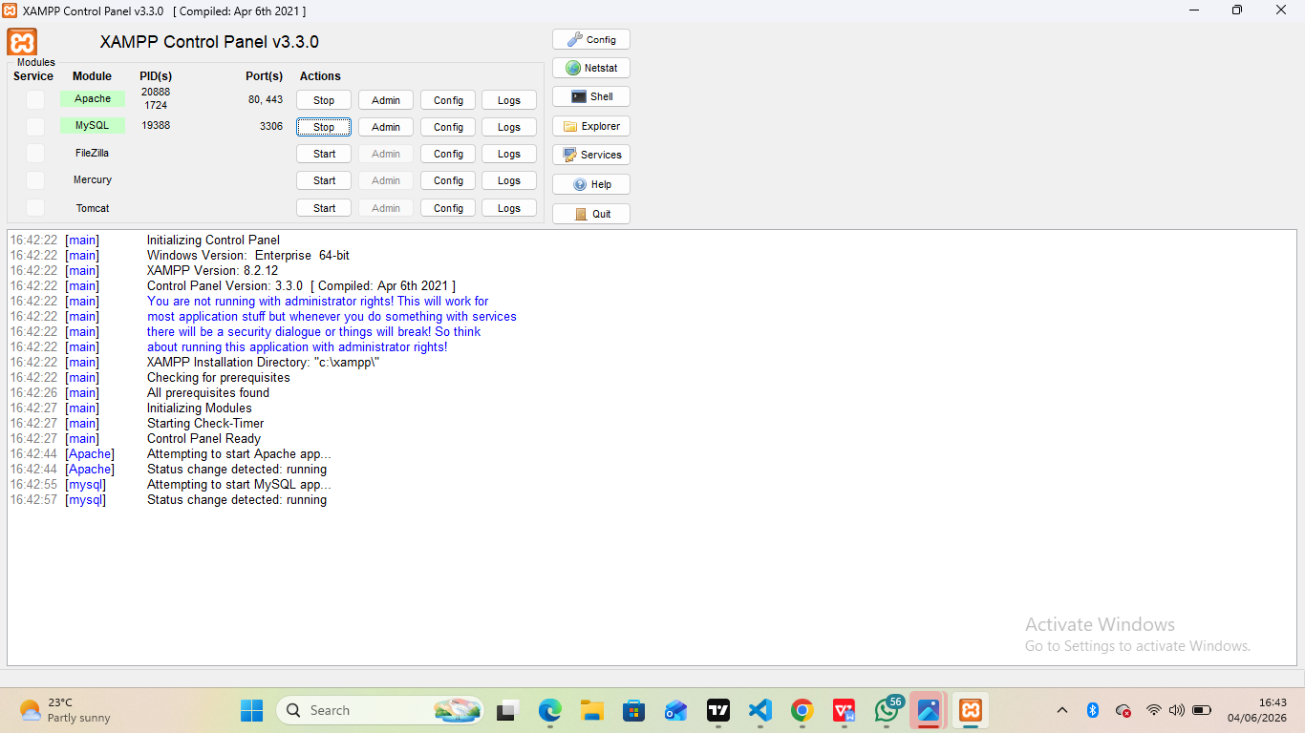
Fig 1.

Localhost Test Page.

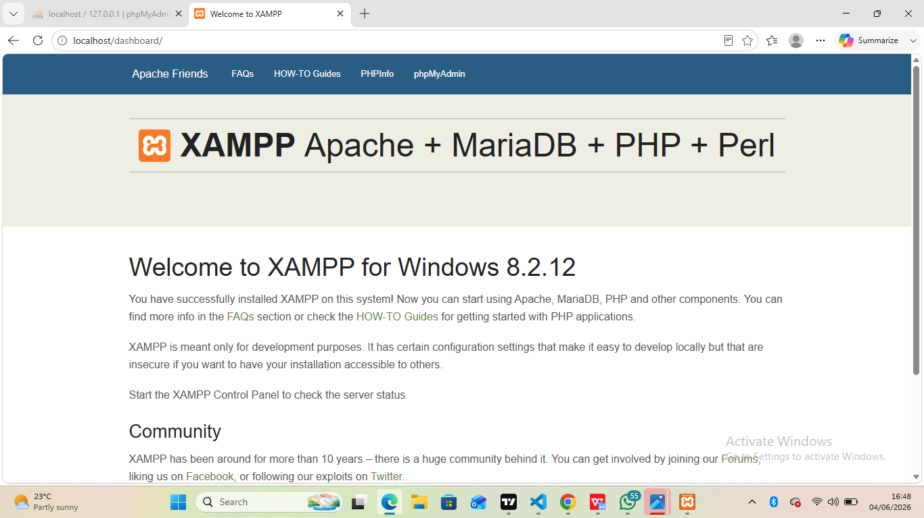
Fig 2

Hello World test
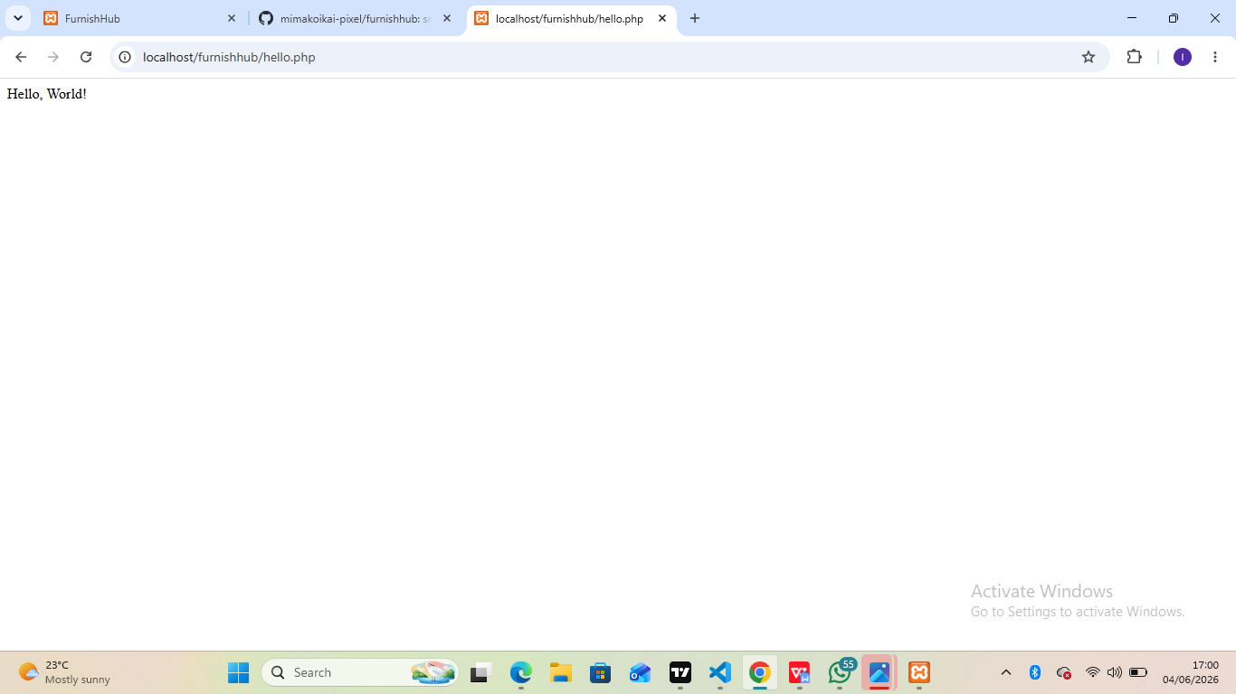
Fig 3

Database test connection

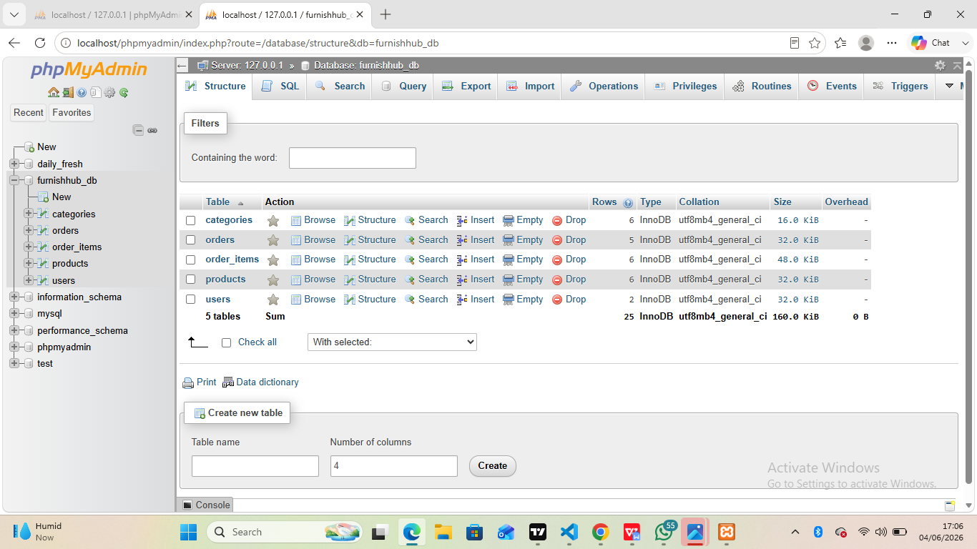
Fig 4

Week 1 Reflection
Week 1 involved setting up the local development environment using XAMPP, PHP, MySQL, and phpMyAdmin. The main challenge was testing and verifying database connectivity between PHP and MySQL. Through these activities, I learned how to connect MySQL to PHP.fig 1shows Apache andMySQL Running using mysqli_connect().fig 4 shows connection between PHP and MySQL confirming successful DB connection.

WEEK 2.WireFrames and GUI Design

User Interface Planning and Systems Design
Dashboard Layout
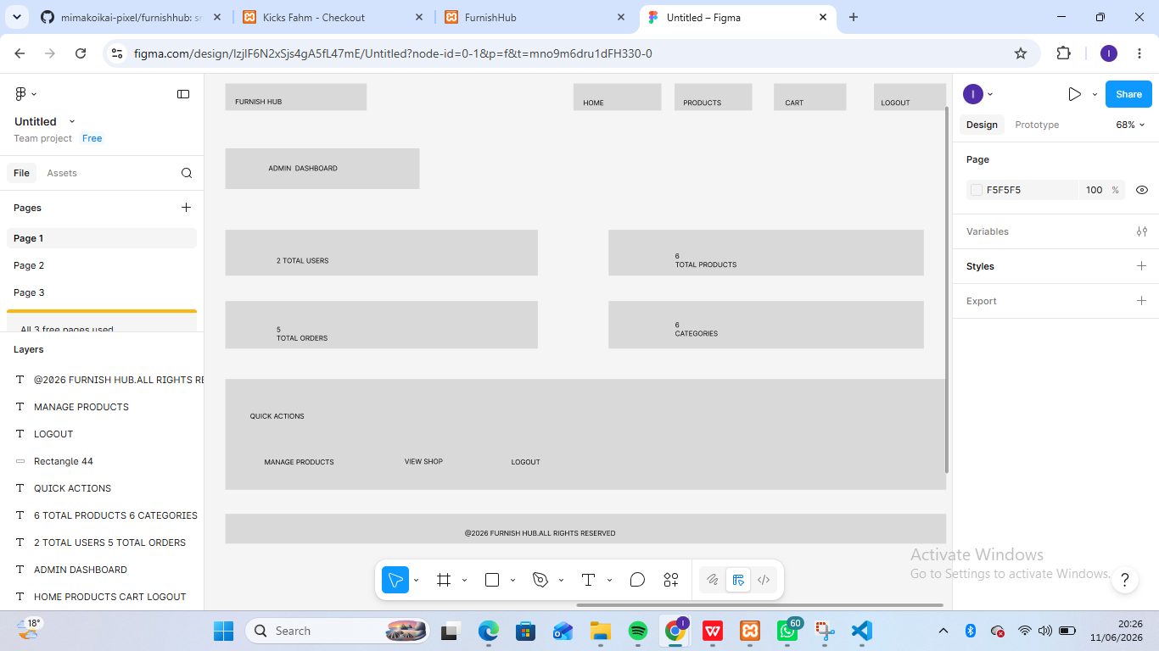

(FIGMA)
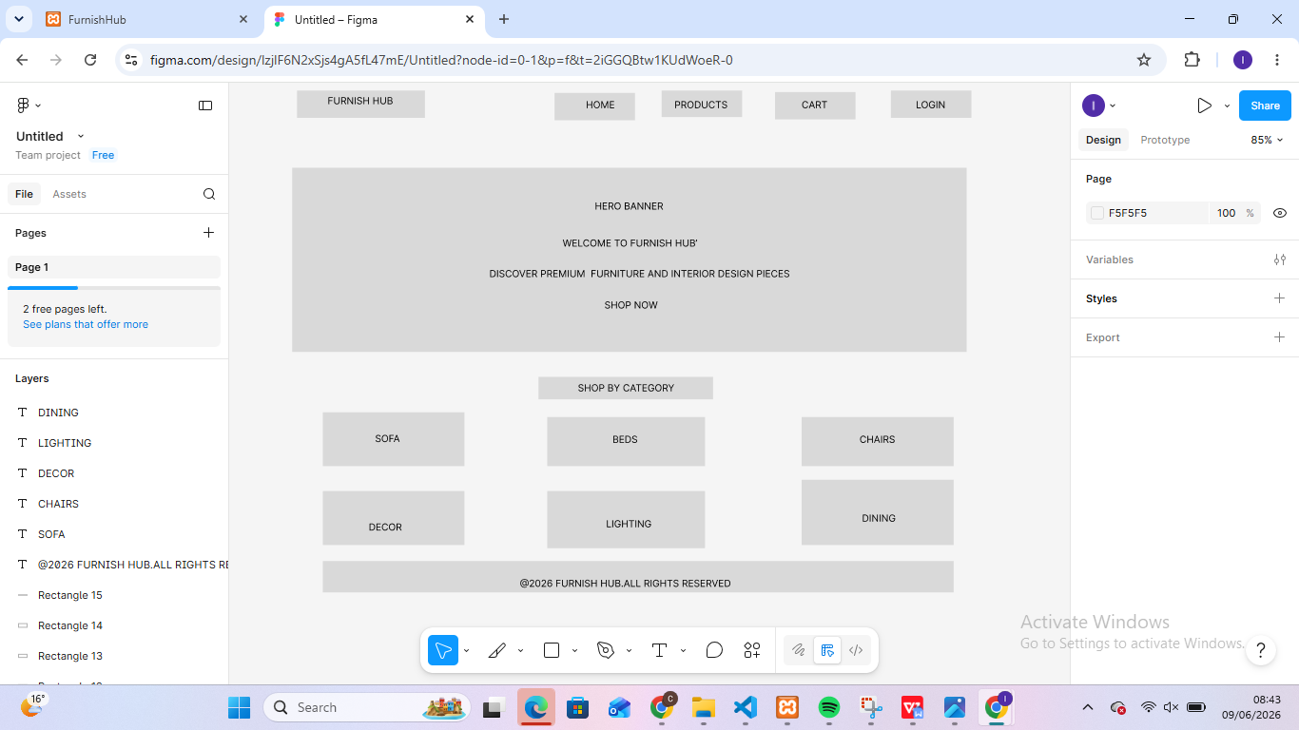
Fig 5

(Draw io)
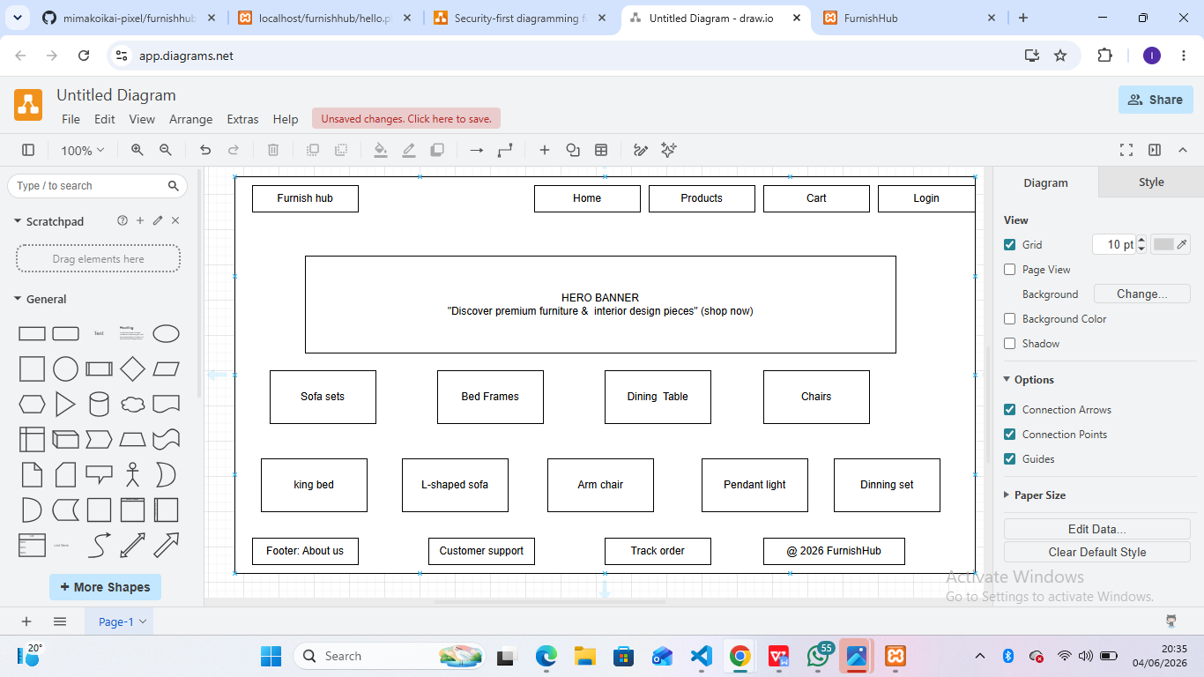
Fig 6

Mobile view mock up
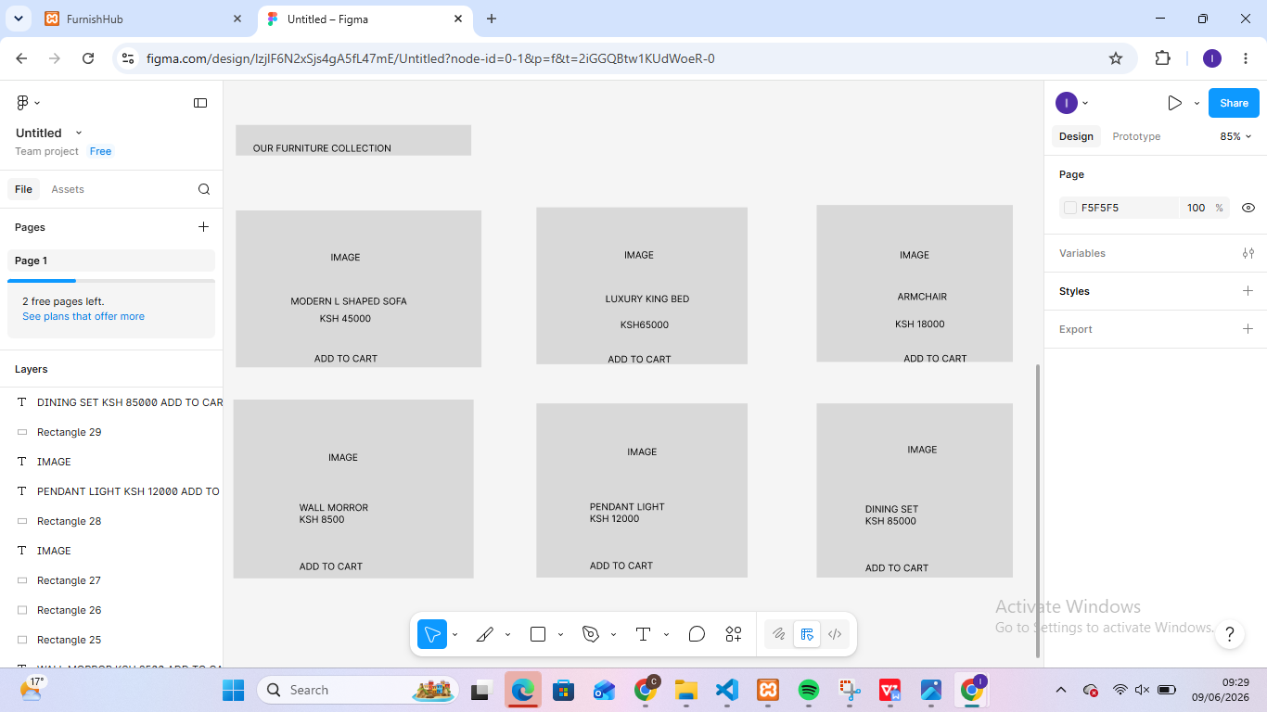
Fig 7
Figma link:https://www.figma.com/design/lzjlF6N2xSjs4gA5fL47mE/Untitled?node-id=1-12&m=dev&t=qCSBjHDpHDx1OUQm-1

WEEK 2 :Reflection
The homepage was designed to enable users to register login and view products.In the products pge users are able to view products and add to cart.The navigation bar was placed on the right top conner for easier accesibility and scalability.

WEEK 3.JAVASCRIPT &PHP basics

Javascript Form validation
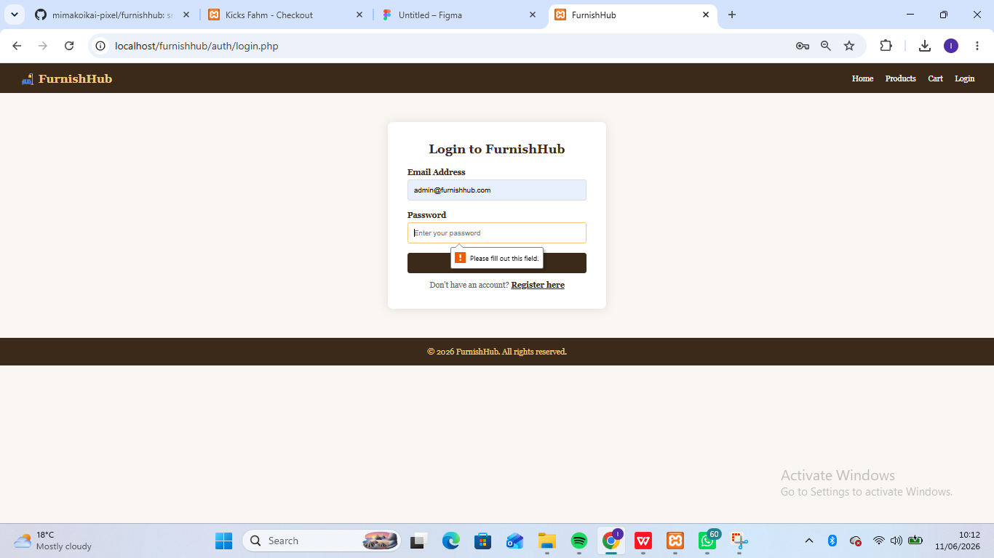

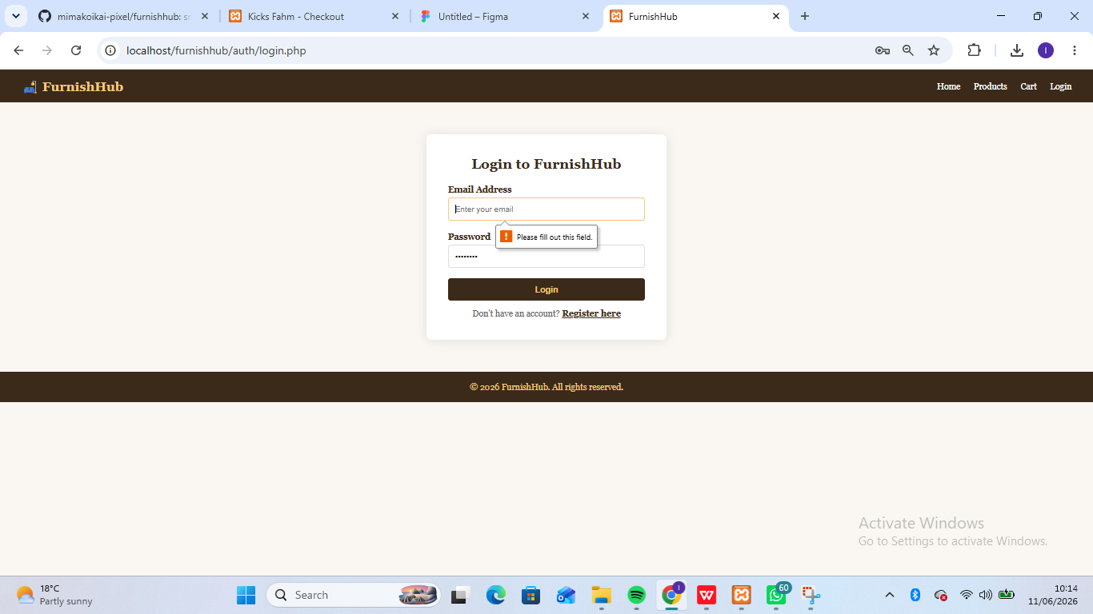

Frontend Interactions and Backend Foundations.
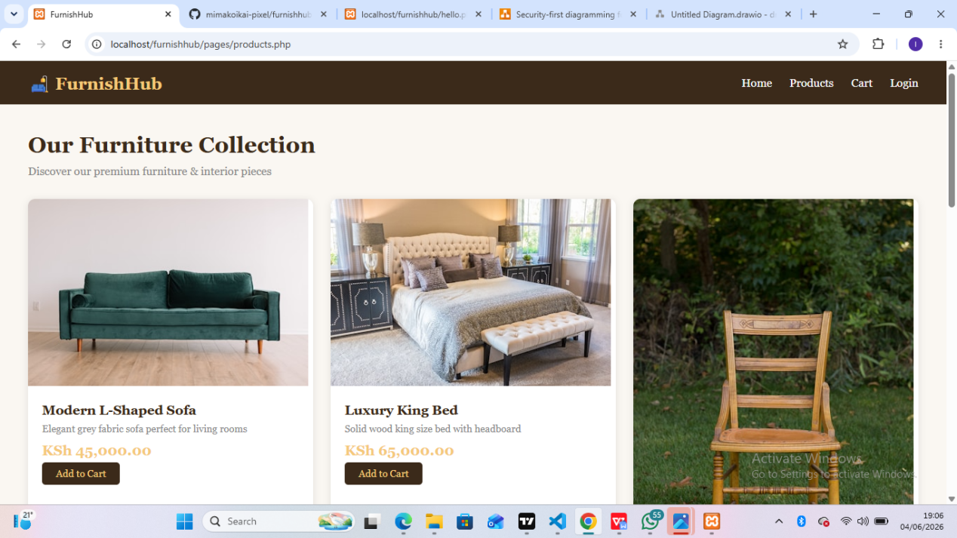
Fig 8

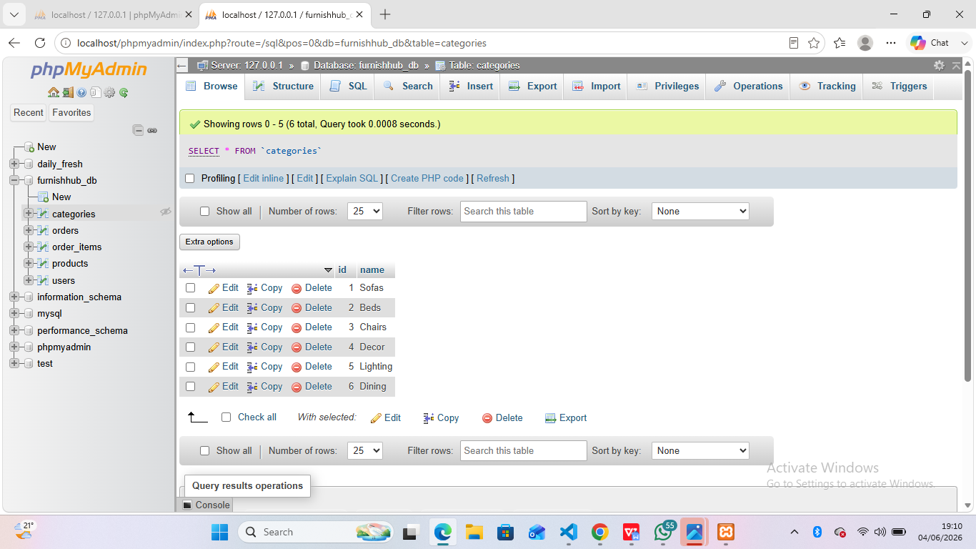
Fig 9

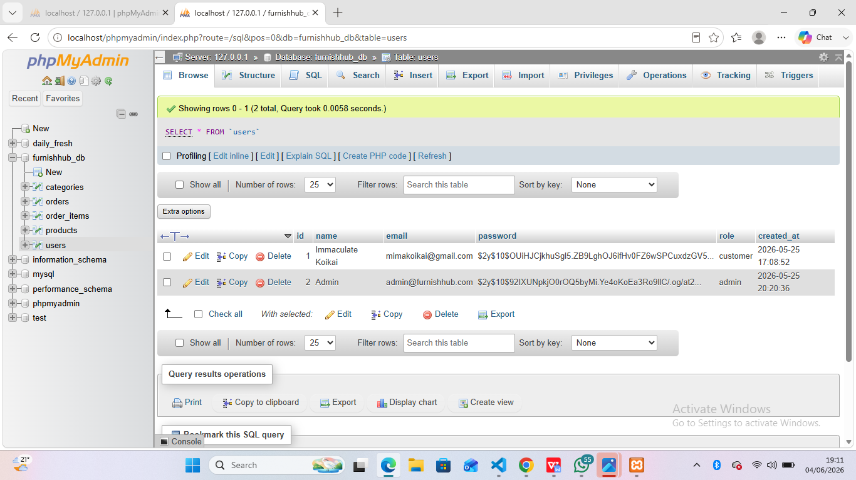
Fig 10

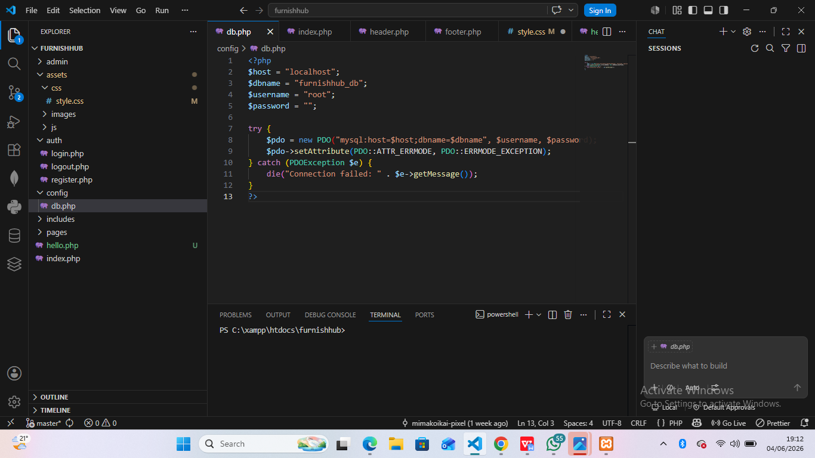

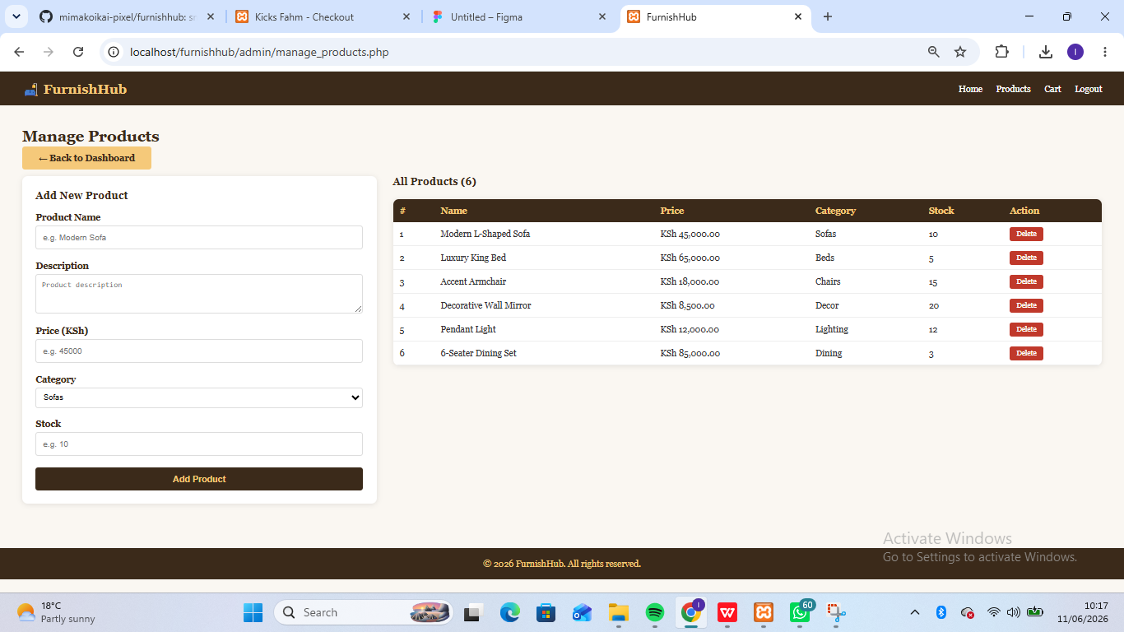
Fig 11

Reflection
Week 3 focused on developing the foundational functionality required for user registration and authentication within the e-commerce system. JavaScript was used to validate form inputs and implement a password strength checker, providing immediate feedback on password quality before submission. PHP was tested for processing registration and login data, while MySQL was used to support storage and retrieval of user records. Establishing database connectivity was necessary to enable communication between application forms and stored data. The screenshots demonstrate validation logic, password strength evaluation, PHP processing, database connection scripts, and confirmed dynamic handling of user input.

GIT HUB
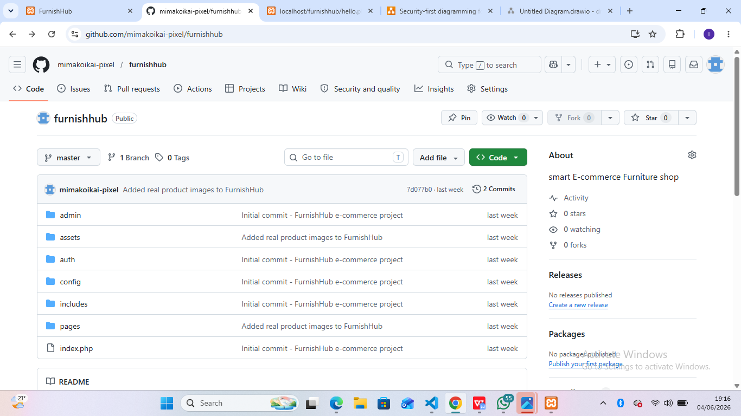
Fig 12

WEEK 4.User authenticaton and backend intergration

Login page
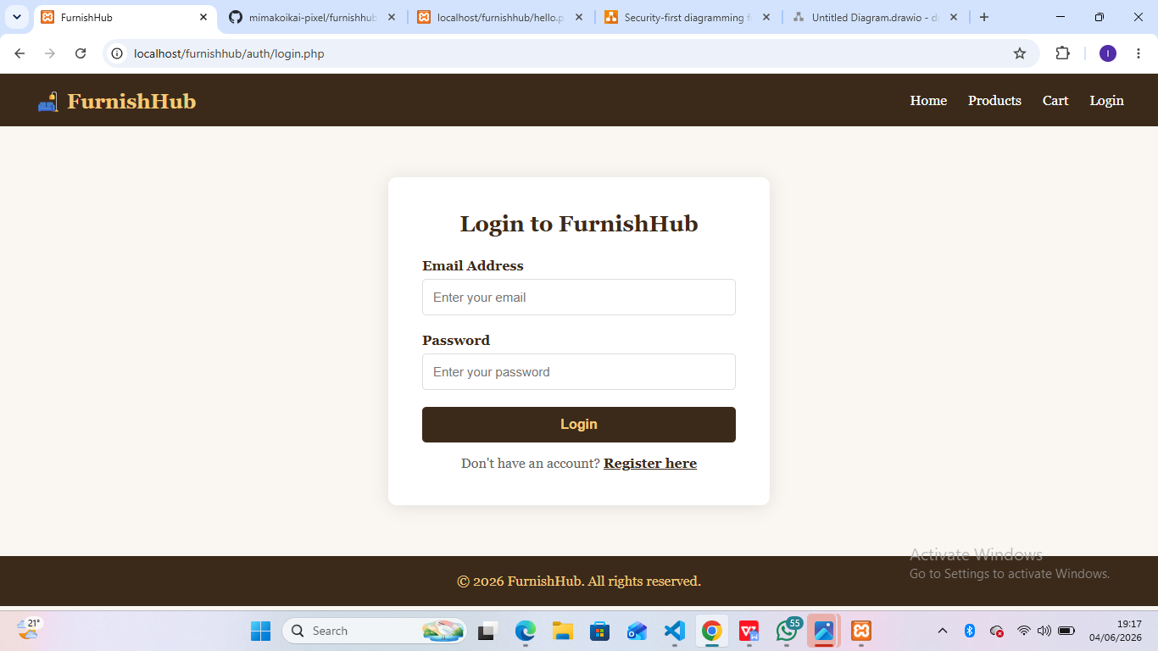
Fig 13

Register page
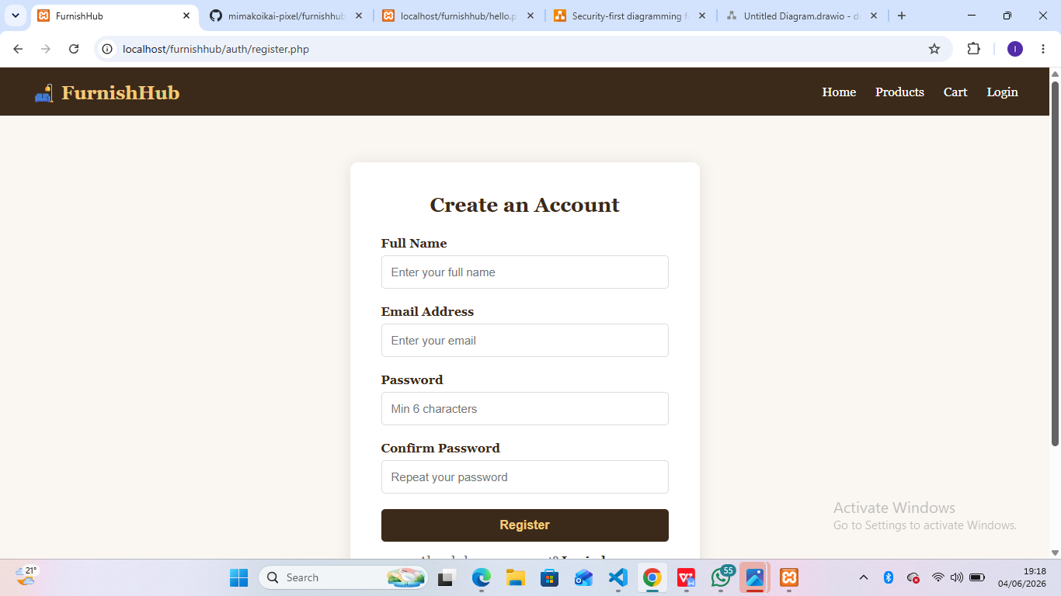
Fig 14

Reflection

Week 4 focused on implementing user authentication using HTML, CSS, PHP, MySQL, and session management. Login functionality was developed to retrieve user records from the users table and verify credentials using password hashing. A challenge encountered was ensuring that form submissions, database queries, and session variables worked together correctly during authentication. The login interface, validation mechanisms, PHP processing logic, database connectivity, and project structure is demonstrated. Successful login testing verified secure authentication and interaction between the user interface, application logic, and database.

VS Code

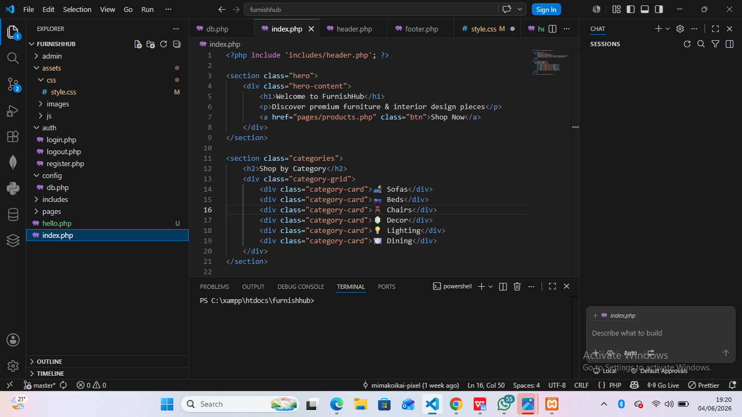
Fig 15

WEEK 5.Database intergration and CRUD operations

DATABASE INTERGRATION.
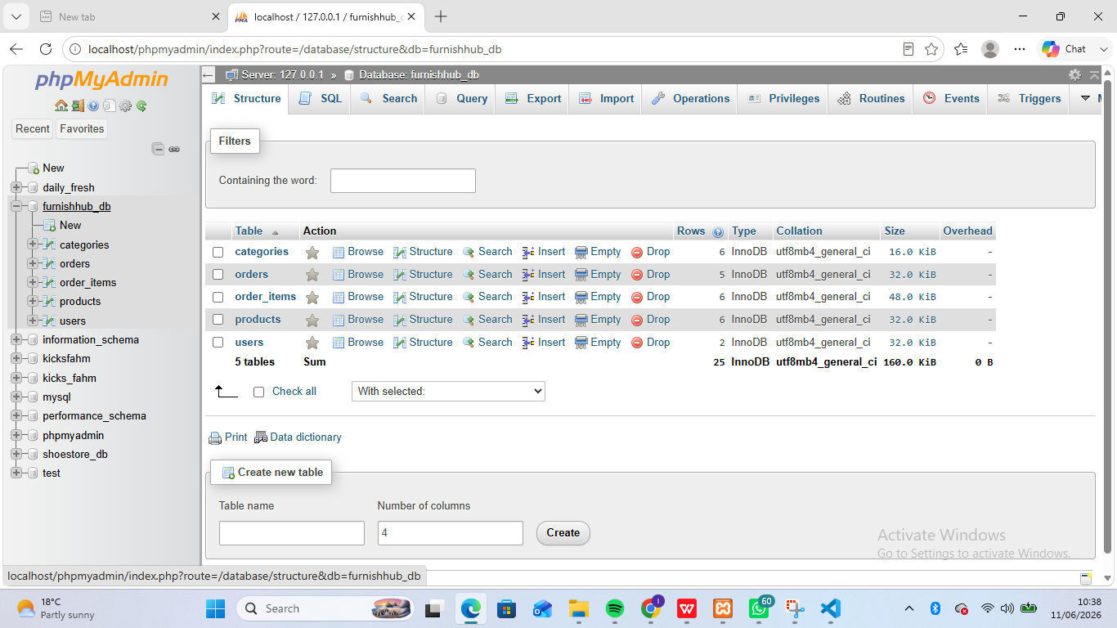

USERS TABLE
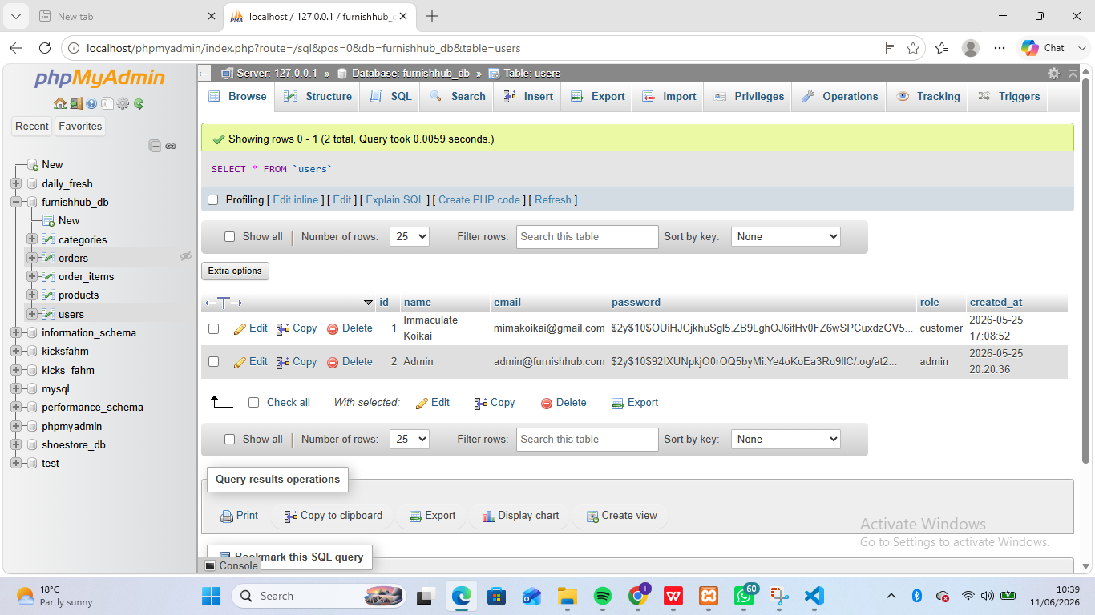
ORDER TABLE
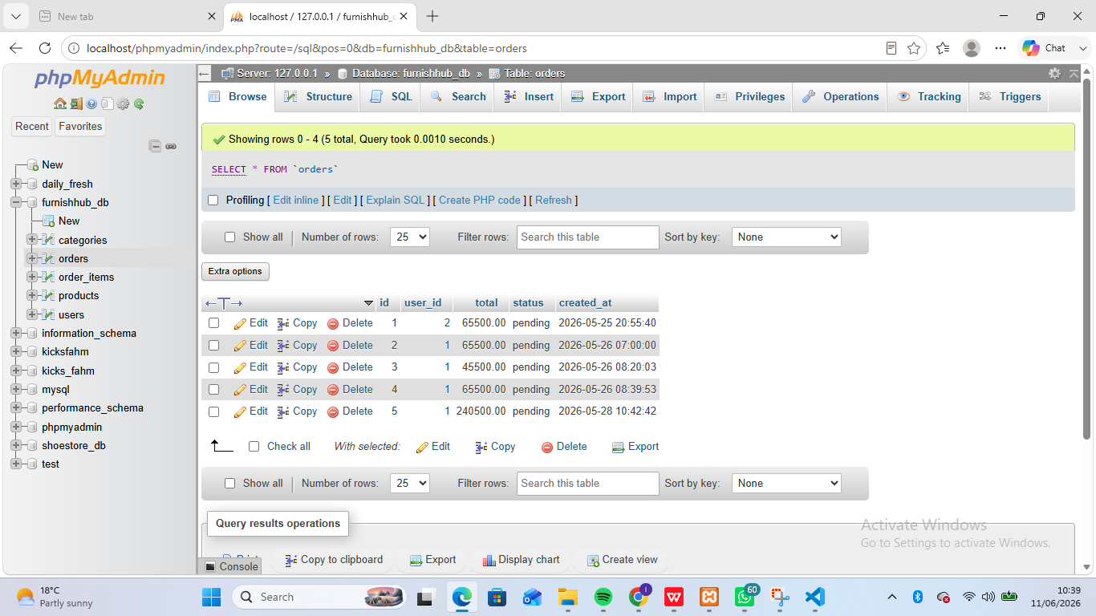

CREATE
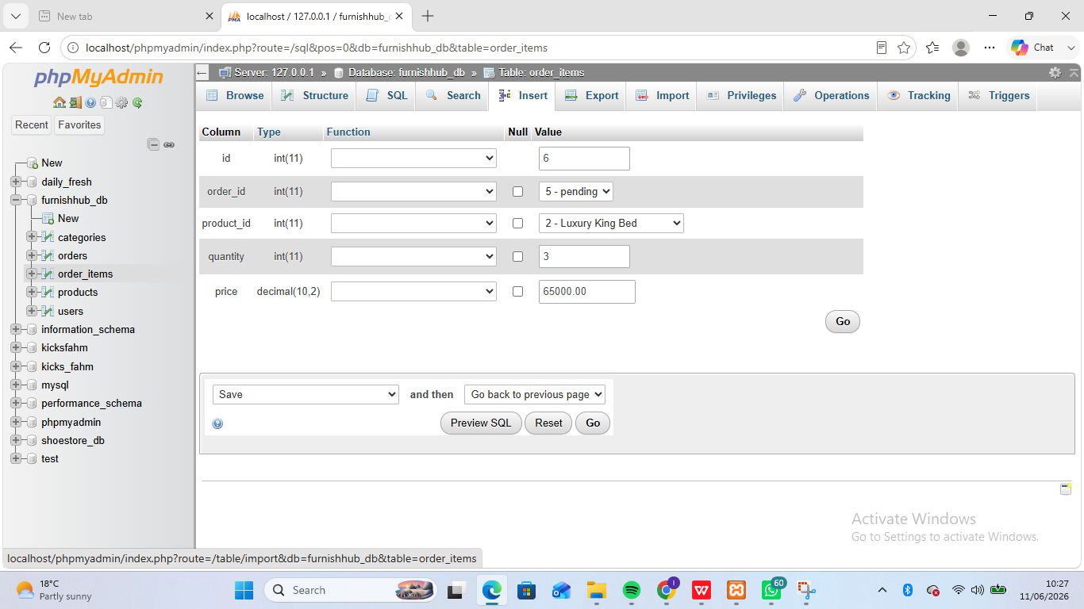
Fig 16

UPDATE
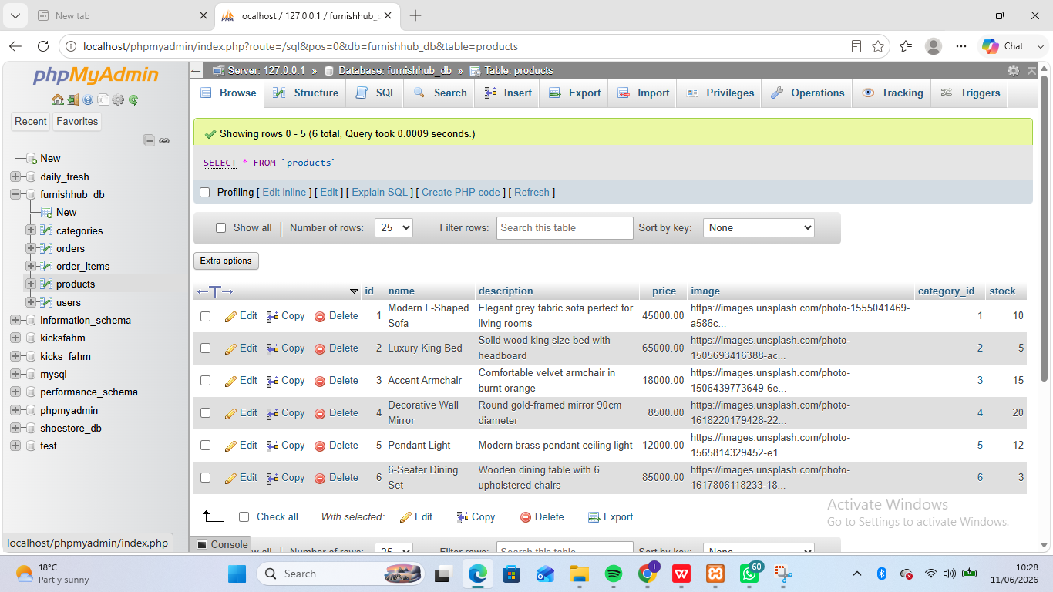
Fig 17

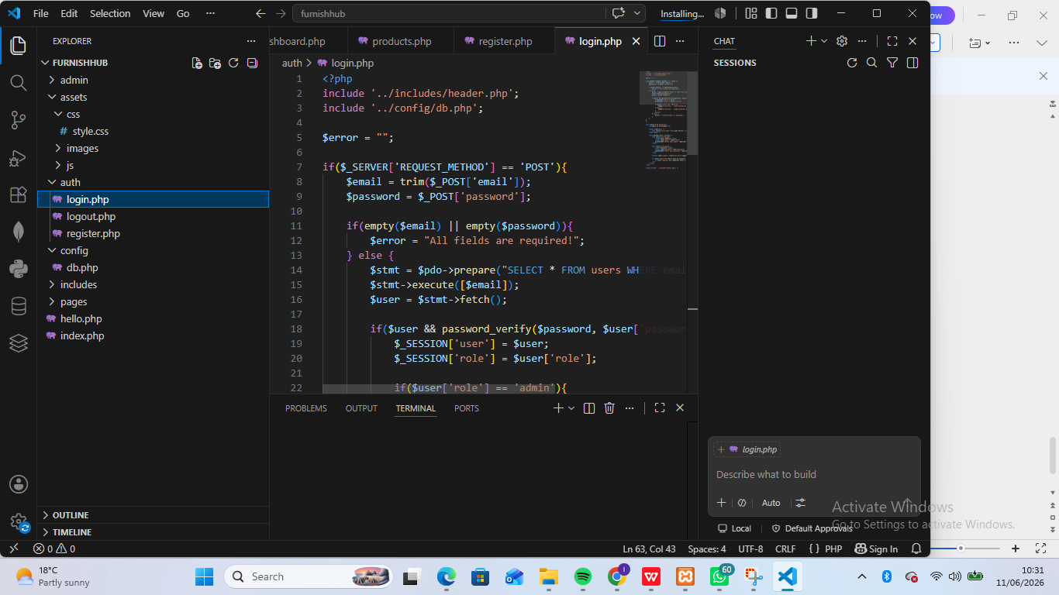
Fig 18

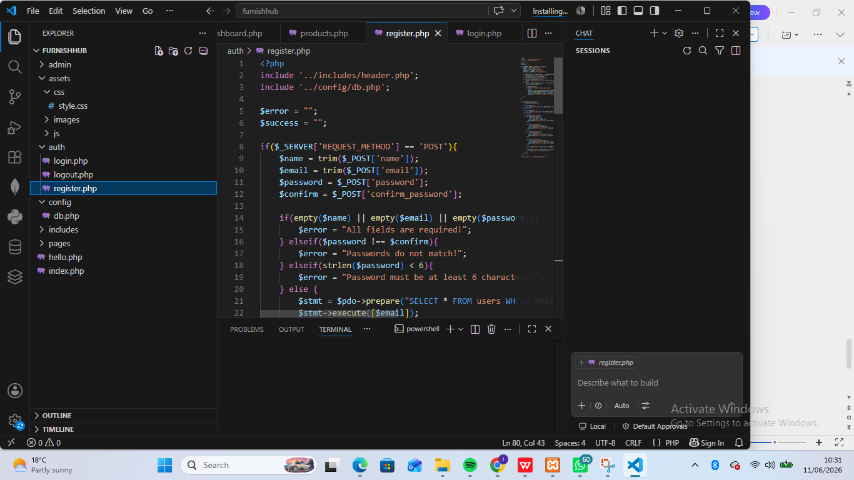
Fig 19

SQL QUERY
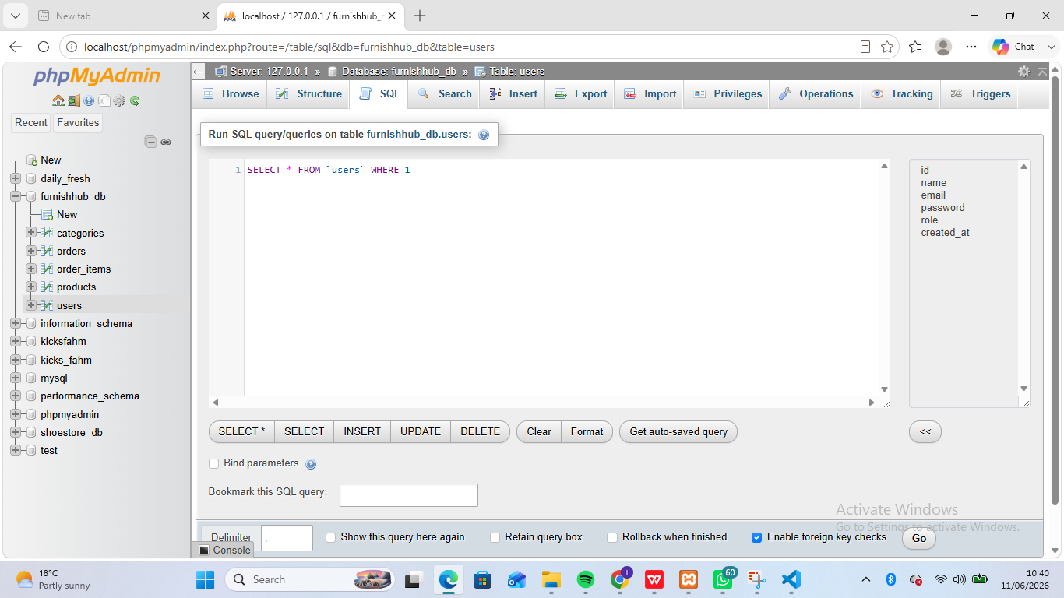

Reflection
Week 5 focused on integrating the application with MySQL and implementing product management functionality. PHP scripts were used to create, retrieve, update, and delete product records stored in the products table. The main challenge was maintaining consistency between form submissions, database updates, and product display pages. The screenshots demonstrate database structure, CRUD operations, authentication queries, and SQL execution. Successful testing verified that product management, user authentication, and database transactions were functioning correctly within the e-commerce system.

WEEK 6:DATABASE INTERGRATION AND CRUD OPERATIONS

Database Structure
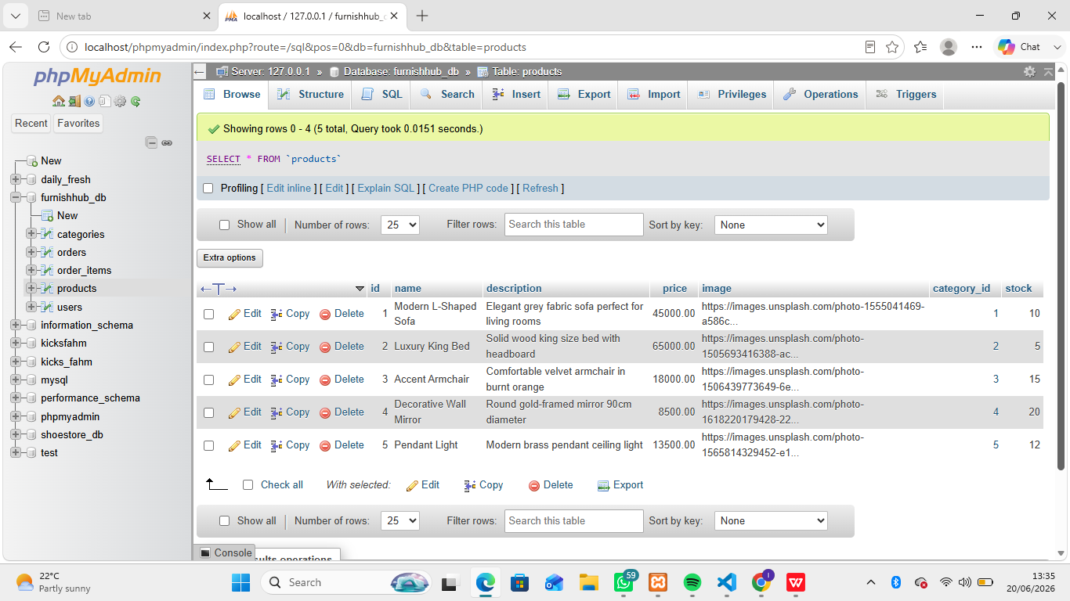

CRUD Operations

Create
Add new product
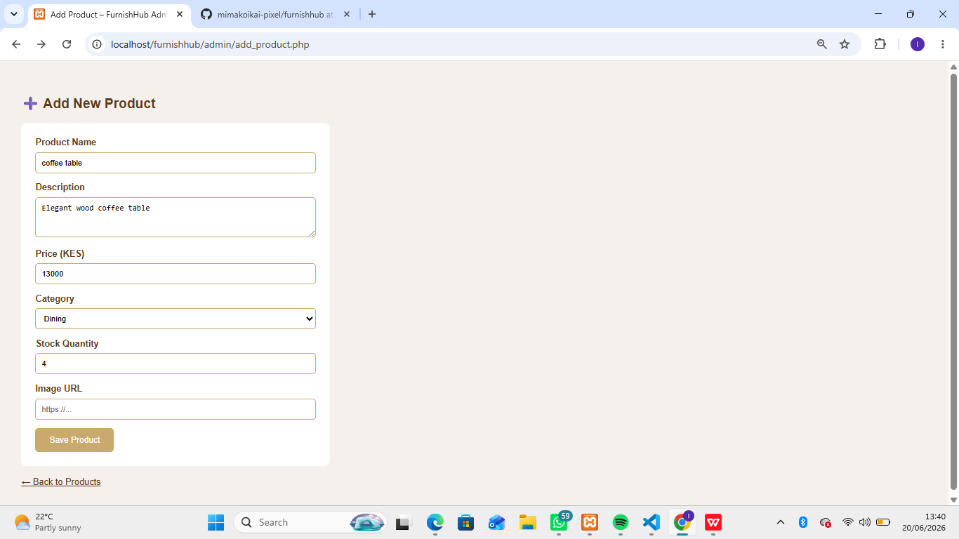
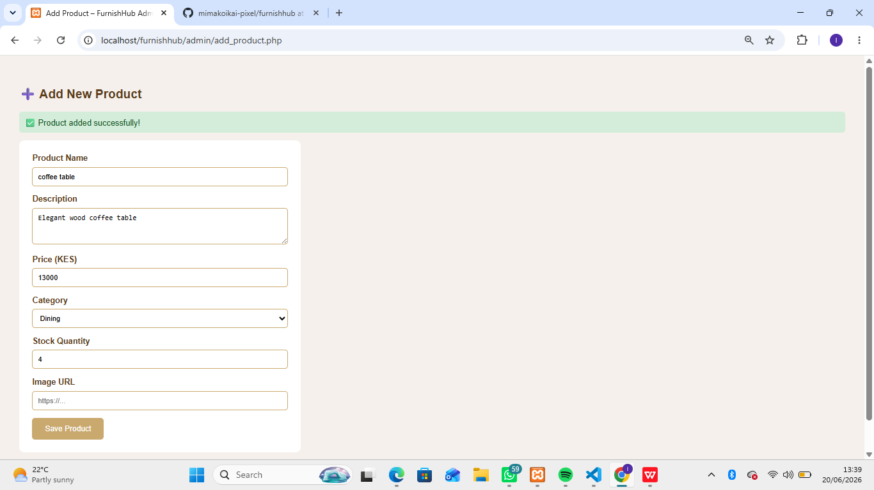

READ
Display all products
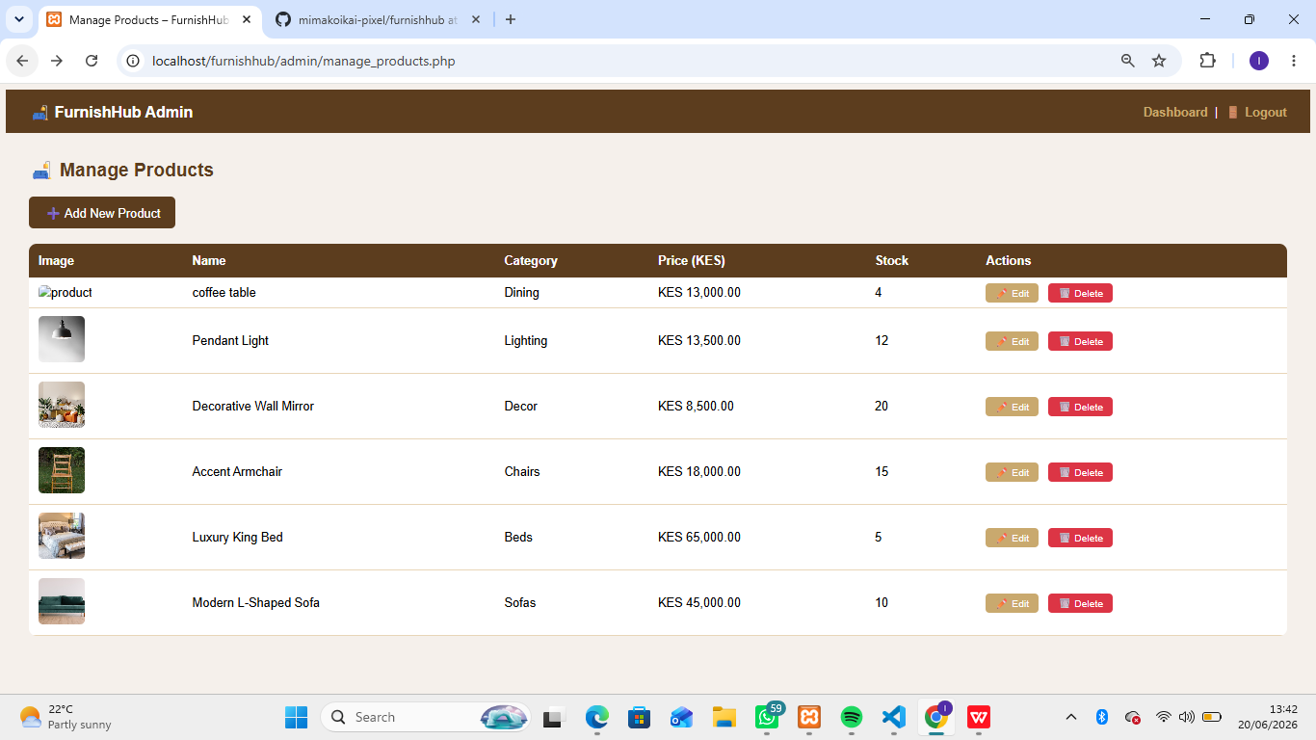

UPDATE
Edit products
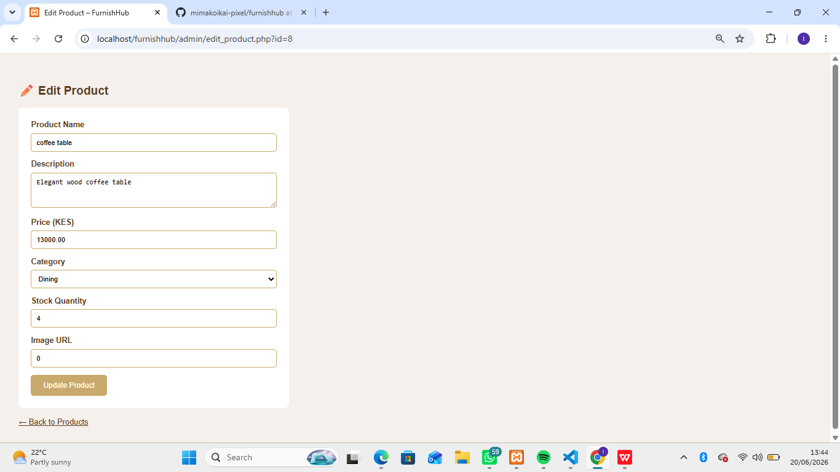

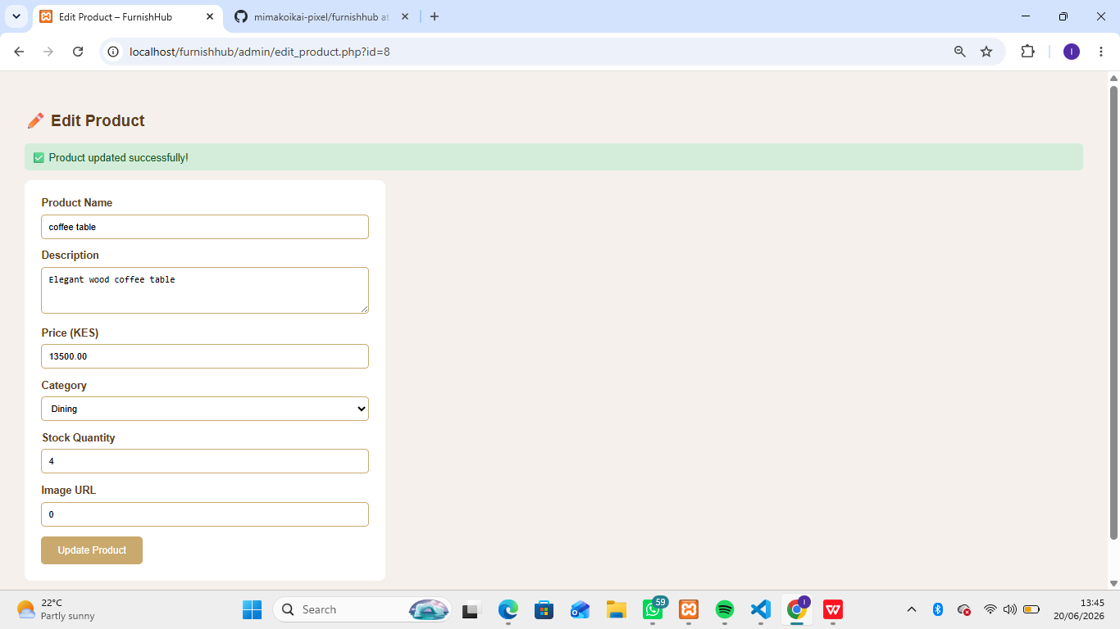

DELETE
Remove Product
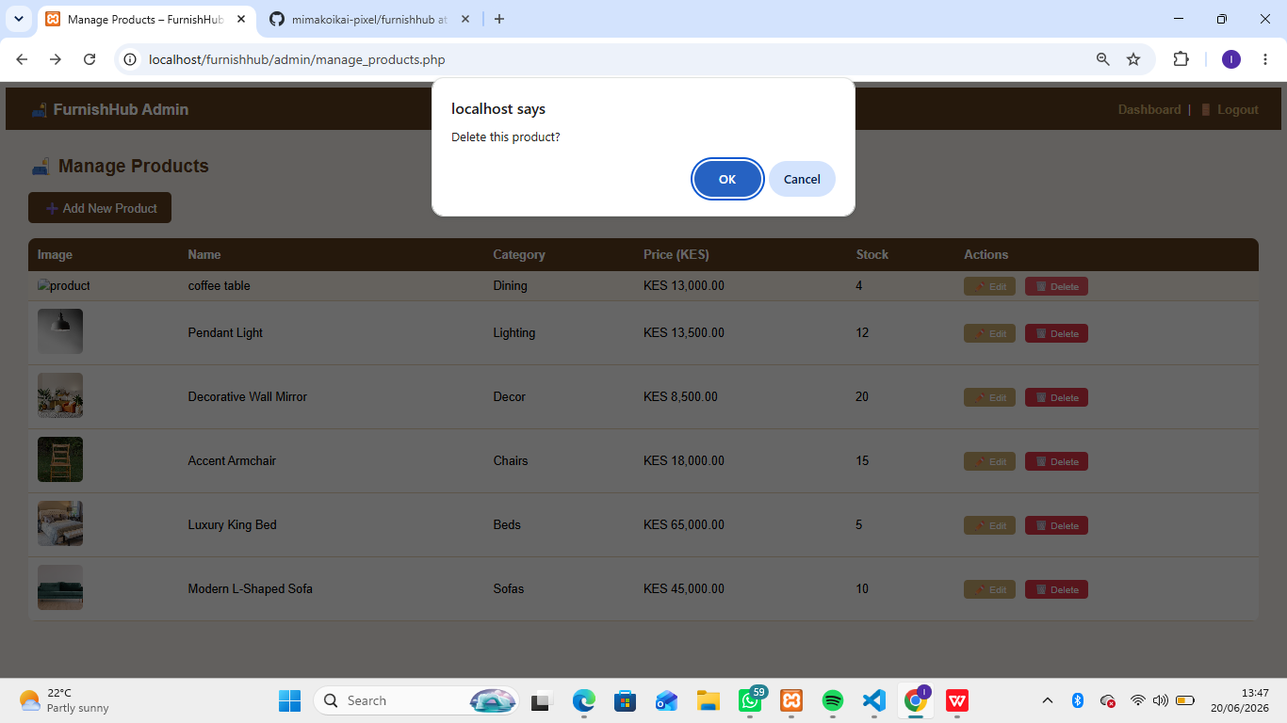

Week 6 :Reflection
In week 6 I successfully impelemented all CRUD operations for furnish hub product management.I also learned how to join tables in SQL to retrieve related data.

WEEK 7:USER AUTHENTICATION AND SESSION MANAGEMENT.
Database set up
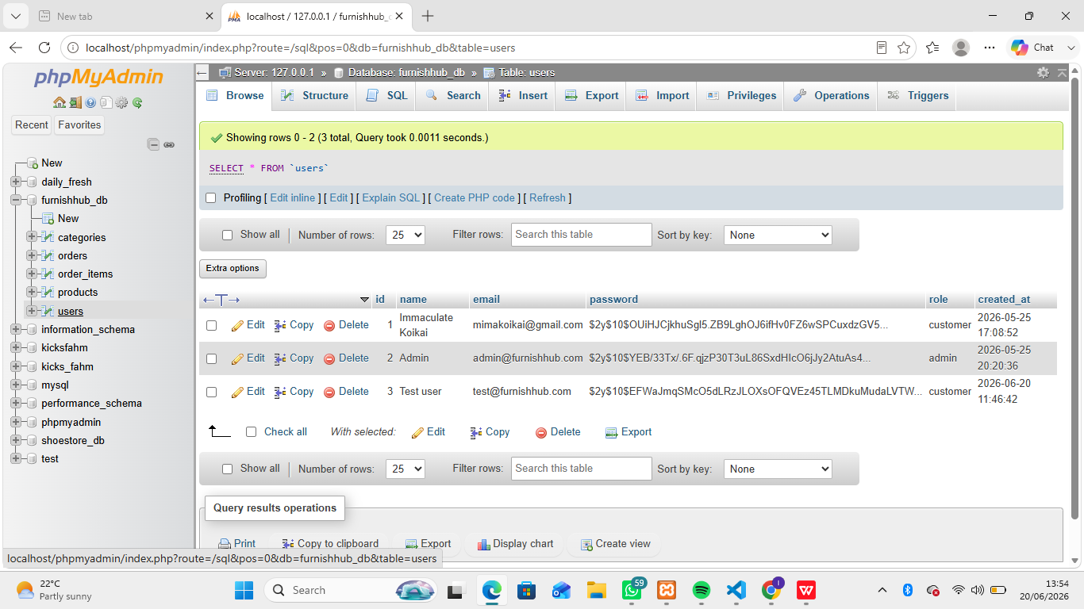

Authentication Implementation

Registration
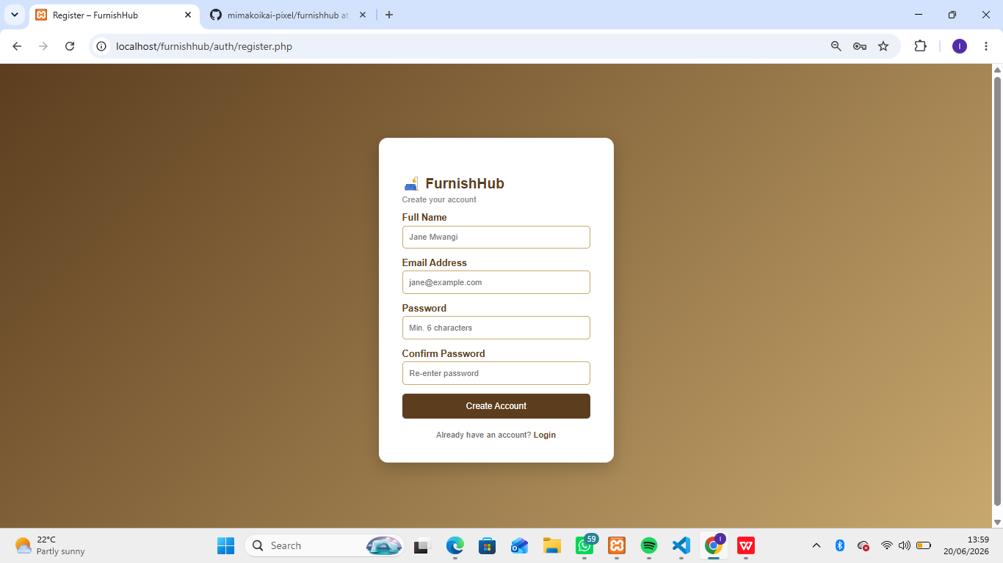

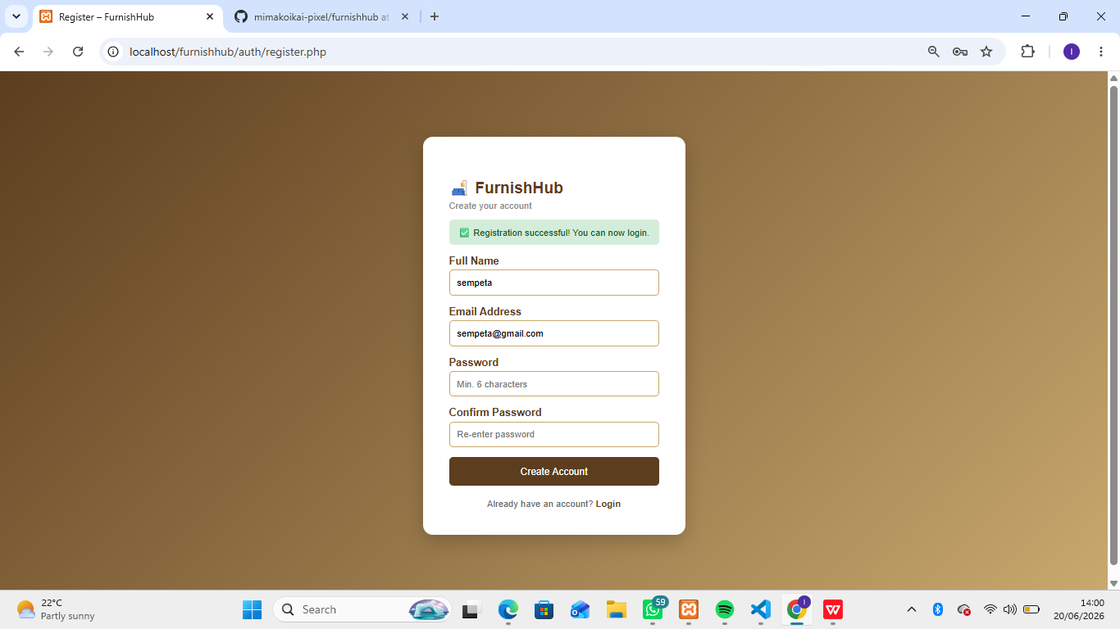

Login
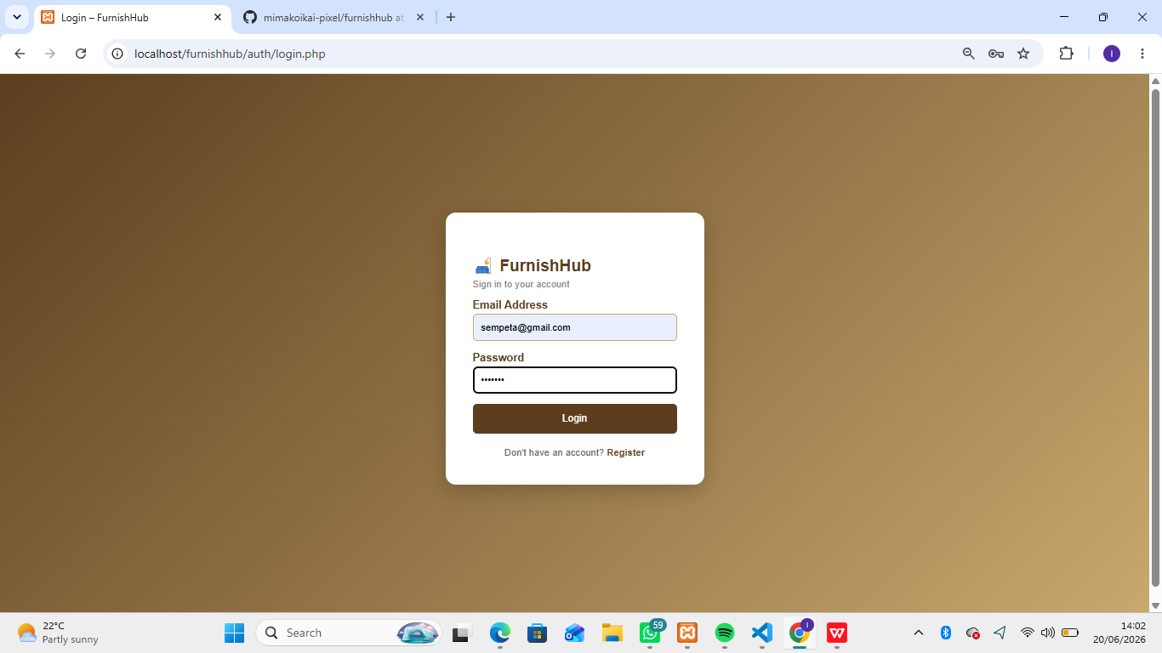

Customer Dashboard
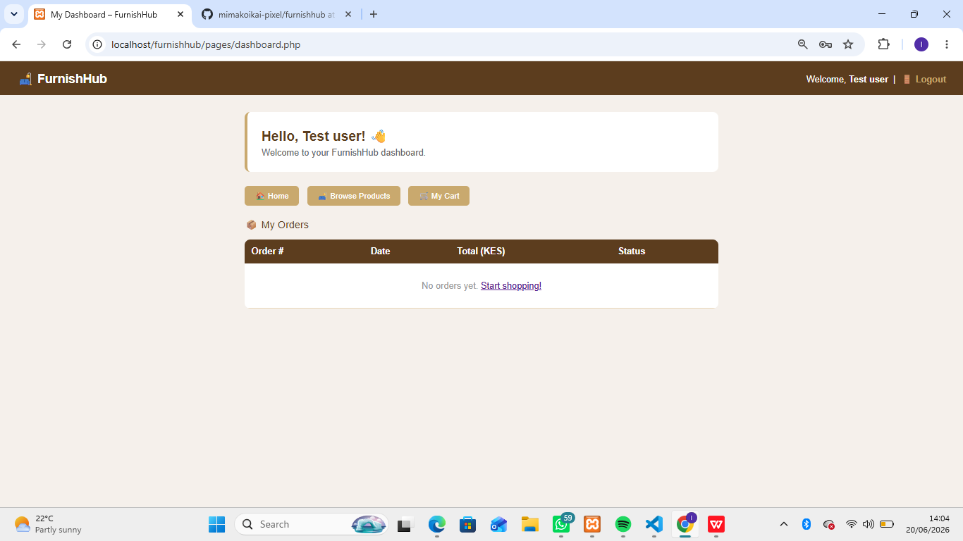

Admin Dashboard
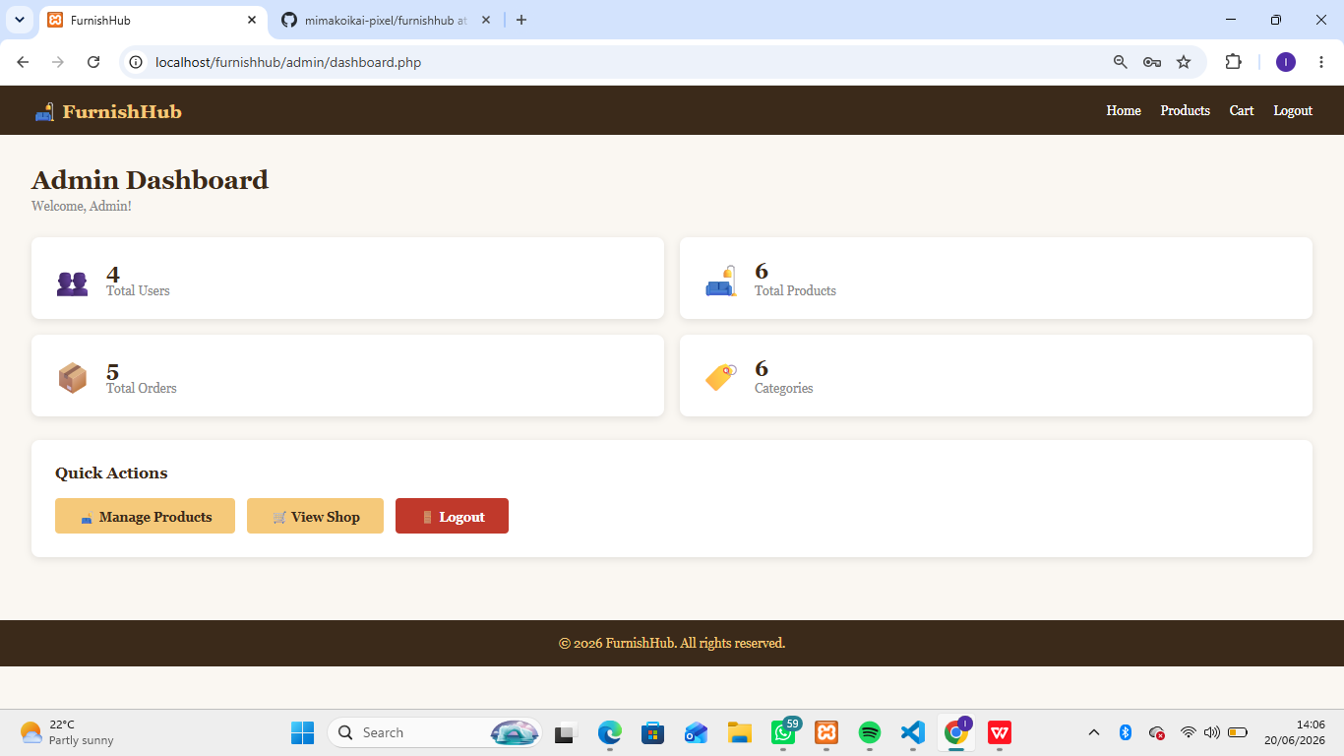

Week 7;Reflection
This week I build a complete authentication system for furnish hub.The most important concept was password hashing storing plain text passwords is a security risk.using password hashing ensures even if the database is compromised passwords cannot be easily read.

